**HUNTER BRACKET WALL MOUNTED FANS:**

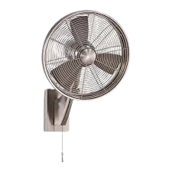

**Price: 8,000.00**

The Hunter Seville wall-mounted fan is designed for efficient air circulation while adding a touch of elegance to your space. With its sleek design and three-speed settings, this fan ensures you can easily control the airflow to suit your comfort levels. Its whisper-quiet motor allows for undisturbed relaxation or productivity, making it perfect for living rooms, bedrooms, or offices. The fan also features a tilting head, allowing you to direct the airflow precisely where you need it.

**Key features of hunter bracket wall mounted fans include:**

1. **Durability:** Built with high-quality materials for long-lasting performance.
2. **Powerful Airflow:** Provides strong and consistent air circulation for larger spaces.
3. **Adjustable Angles:** Allows flexibility in directing airflow where needed.
4. **Quiet Operation:** Designed to minimize noise while running.
5. **Space-Saving Design:** Wall-mounted setup to save floor space.
6. **Multiple Speed Settings:** Offers different airflow speeds for varied comfort levels.
7. **Versatility:** Suitable for both residential and commercial environments.

Top of Form

Bottom of Form